**Firewall**

* A firewall keeps the network and everything in it as secure as possible from potential attacks.
* It analyzes data that is passing back and forth in a network, and based on a set of rules that have been configured, determines whether or not the information should be allowed to proceed.
* 4 different types of firewall architectures:

1. Packet Filtering Routers
2. Screened Host Firewalls
3. Dual-Homed Host Firewalls
4. Screen Subnet Firewalls (with DMZ) [Dominant architecture used today]

* (http://www.idc-online.com/technical_references/pdfs/data_communications/Firewall_Architectures.pdf)

Third-party firewalls are a solid option as it’ll require much less maintenance on our part.

**Web Server**

Leading web servers:

* Apache (most installed web server)

Internet Information Server by Microsoft

* nginx by NGNIX
* NetWare server by Novell
* Google Web Server (GWS)
* IBM’s family of Domino servers

Delivers the files that create the web pages (HTTP content) to users which are read by the browser.

**Application Server**

An application server can serve content in addition to HTTP content, so there are no restrictions on them. It provides all the runtime and software frameworks needed to create and run web-based apps. It acts as a go-between for the database server and the users of the business or

consumer apps it supports.

Application servers can also contain their own GUIs for management through PCs, but it can also take care of their own resources (transaction processing, messaging, resource and connection pooling, and performing security tasks).

Popular Application Severs:

* J2EE
* WebLogic
* Glassfish
* JBoss Enterprise Application Platform (now known as WildFly)
* Apache Tomcat
* Apache Geronimo

**Persistent Layer (Database)**

…

**Angular**

Architecture Overview:

* Angular is a platform and framework for building client applications in HTML and TypeScript
* Angular is written in TypeScript

**Other**

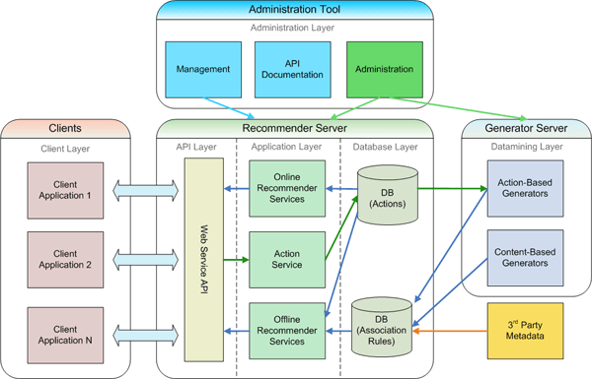

* Single-page application
  + Usually JavaScript (Angular should be possible)